PRACTICAL FILE

COURSE : SOFTWARE ENGINEERING METHODOLOGIES
SUBJECT CODE : SE-209n
B.TECH SEMESTER-V



^{DELHI TECHNOLOGICAL UNIVERSITY}
(FORMELY DELHI COLLEGE OF ENGINEERING)
^{BAWANA ROAD , DELHI – 110042}

^{SUBMITED BY : NAMAN SAGAR}
^{ROLL NO . : 23/MC/093}
SUBMITED TO : Mr. AYUSH AWASTHI
INDEX
S.No. | Experiments | Date | Remarks
1. | Write a problem statement on the Online Course Registration system.
2. | Design a use case diagram on the Online Course Registration system.
3. | Write a brief description about use case diagram.
4. | Draw level 0, 1, and 2 DFD (Data Flow Diagram) on the Online Course Registration system.
5. | Draw E-R diagram (Entity-Relationship diagram) of the Online Course Registration system.
6. | Draw a class diagram for the Online Course Registration system.
7. | Write/design SRS (Software Requirements Specification) for the Online Course Registration system.
8. | Design test cases for the inventory management system using boundary value method. (Note: This task specifically mentions inventory management and was not changed.)
9. | Write a program in C to implement COCOMO model.
10. | Write a program in C to implement function point method.

Experiment 1

AIM: Write a problem statement on the Online Course Registration system.

Introduction:
Online course registration systems have revolutionized the academic enrollment process by enabling students to register for courses remotely, eliminating the need for physical presence and reducing administrative burdens. Traditional registration methods required students to visit institutions, fill out paper forms, and wait for approvals, which was time-consuming and inefficient. With online course registration, students can browse available courses, check seat availability, register, and receive instant confirmation. This digital transformation enhances accessibility, reduces errors, and streamlines academic administration.

Hardware Requirements:
- Server: To host the registration system and store student and course data.
- Computers/Laptops: Used by students and administrators to access the system.
- Internet Connection: Required for remote access and real-time updates.
- Database Storage: To manage large volumes of student and course information.
- Security Devices: Firewalls and encryption to ensure data protection.

Software Requirements:
- Operating System: Windows, Linux, or macOS for hosting and accessing the system.
- Database Management System (DBMS): MySQL, PostgreSQL, or Oracle to store and manage data.
- Web Server: Apache or Nginx for hosting the web-based application.
- Front-End Framework: React, Angular, or Vue.js for a user-friendly interface.
- Back-End Framework: Django, Node.js, or Laravel to handle user authentication and data processing.
- Security Software: SSL encryption and authentication mechanisms to protect user data.

Functional Requirements:
- User Registration: Students and faculty members should be able to create accounts.
- Course Selection: Students should browse and select available courses.
- Real-Time Seat Availability: Display the number of available seats per course.
- Schedule Management: Ensure students do not enroll in conflicting courses.
- Payment Integration: Enable fee payments for premium courses if applicable.
- Automated Confirmation: Send instant notifications upon successful registration.
- Admin Dashboard: Allow administrators to add, modify, and remove courses.

Non-Functional Requirements:
- Scalability: The system should support a growing number of users.
- Security: Secure user credentials and personal data with encryption.
- Availability: The system should be accessible 24/7 with minimal downtime.
- Performance: Fast response times for queries and registration processes.
- Usability: Intuitive and user-friendly interface for easy navigation.

Problem Statements:
- Manual Registration Hassles: Traditional registration involves paperwork and manual approvals, leading to inefficiencies.
- Limited Registration Windows: Fixed working hours restrict students from registering at their convenience.
- Scheduling Conflicts: Overlapping classes create confusion for students and administrators.
- Data Inconsistencies: Manual errors can lead to incorrect course enrollments.
- Lack of Transparency: Students may not have real-time information on seat availability.
- Payment Challenges: Without online payment options, fee processing is delayed.
- Administrative Overload: Staff need to process each registration manually, leading to delays.

Conclusion:
The transition from manual to online course registration streamlines the enrollment process, enhances user experience, and improves operational efficiency. By implementing a digital solution, students can register seamlessly, institutions can manage enrollments effectively, and administrative workloads are significantly reduced. This advancement in academic administration underscores the growing need for technology-driven solutions in education.

Experiment 2

AIM: Design a use case diagram on the Online Course Registration system.

Introduction:
Data Flow Diagrams (DFDs) serve as potent visual tools in systems analysis and design, portraying the flow of data within a system. The process of developing DFD levels for a Course Registration system involves constructing a hierarchical representation of the system's functions and interactions.
Definition:
The development of DFD levels for a Course Registration system encompasses crafting a series of hierarchical diagrams showing the flow of data and processes within the system. The initial level furnishes a broad overview of major components and external entities, while subsequent levels dissect these components into finer details. These diagrams utilize standardized symbols for processes, data stores, data flows, and external entities, facilitating the analysis, design, and communication of the Course Registration system's structure and functionality. The multi-level approach facilitates a step-by-step exploration of the system's intricacies, augmenting clarity and comprehension for stakeholders involved.
Types of DFDs, Their Definitions, and Diagrams
A DFD of a Course Registration System consists of two levels: Level 0 DFD, Level 1 DFD, and Level 2 DFD.
Level 0 DFD
DFD Level 0, recognized as a Context Diagram, serves as a fundamental overview of a system or process. As the highest level of DFD, it offers a simple, top-level view of the system.
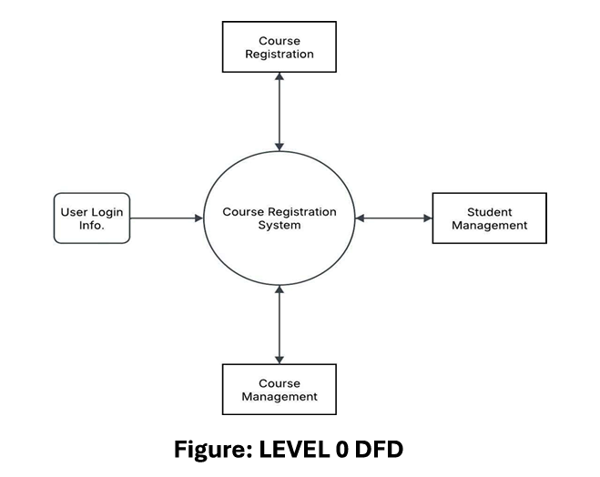
Level 1 DFD
A Level 1 Data Flow Diagram (DFD) provides a general overview, deconstructing a single process node from a context diagram into sub-processes. It can be conceptualized as an "exploded view" of the context diagram.
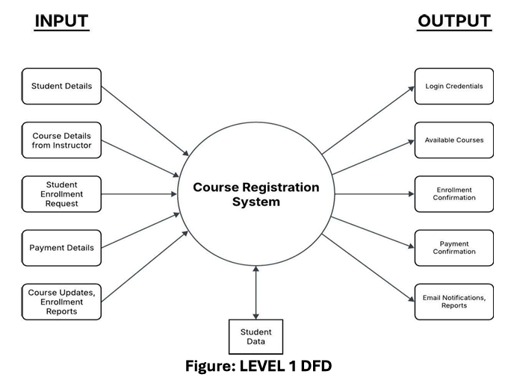
Level 2 DFD
A Level 2 Data Flow Diagram (DFD) supplies a more intricate view of specific processes identified in a Level 1 DFD. It dissects complex processes into smaller, detailed subprocesses, frequently encompassing data stores and flows between them. Level 2 DFDs yield a more granular comprehension of system functionality, proving valuable for system analysts and designers.
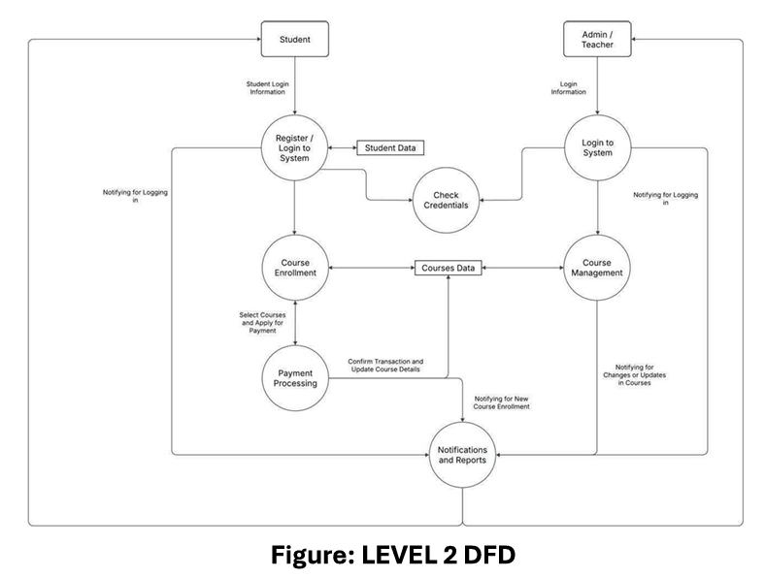
What Level 2 DFD Represents
Processes:
- User Registration/Login (2.1) → Handles student and admin login.
- Course Enrollment (2.2) → Allows students to browse and select courses.
- Course Management (2.3) → Allows admin/teachers to browse and update courses.
- Payment Processing (2.4) → If applicable, manages fee payments for courses.
- Notification System (2.5) → Sends confirmation emails or notifications.
Entities:
- Students → Users who register for courses.
- Admin/Registrar → Manages course availability and student enrollment.
Data Stores:
- Student Database → Stores student profiles and registration records.
- Course Database → Contains course details, availability, prerequisites.
- System Database → Stores student records, course details, and schedules.
Data Flows:
- Student Data → Check Credentials.
- Admin Data → Check Credentials.
- Update Course Details → Courses Data.
- Student Request → Courses Data (Verification).
- Confirmation Details → Student and Admin.
The Level 2 DFD furnishes a more detailed view of data flow between these processes and modules within the Course Registration system, offering an enhanced understanding of the system's internal workings.

Experiment 3

AIM: Write a brief description about use case diagram.

Introduction
A data dictionary is like a guidebook for the Course Registration System, laying out all the key pieces of information (data elements) that the system uses. It explains what the data elements mean, how they are stored, and why they matter, helping to keep everyone on the same page. It covers details like names, data types, sizes, and rules to ensure the system remains organized, accurate, and easy to work with.

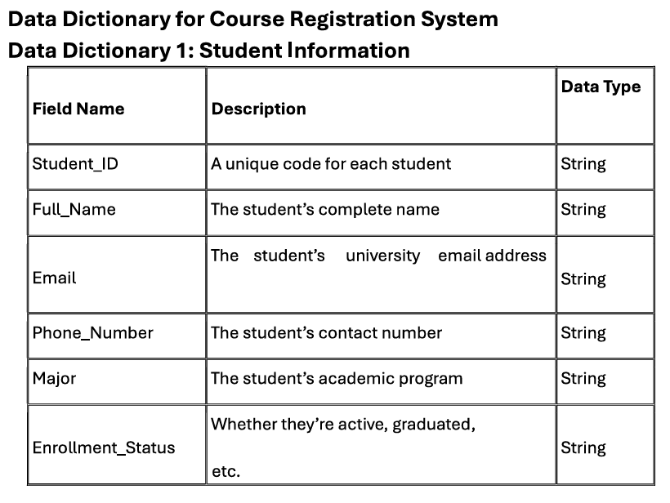

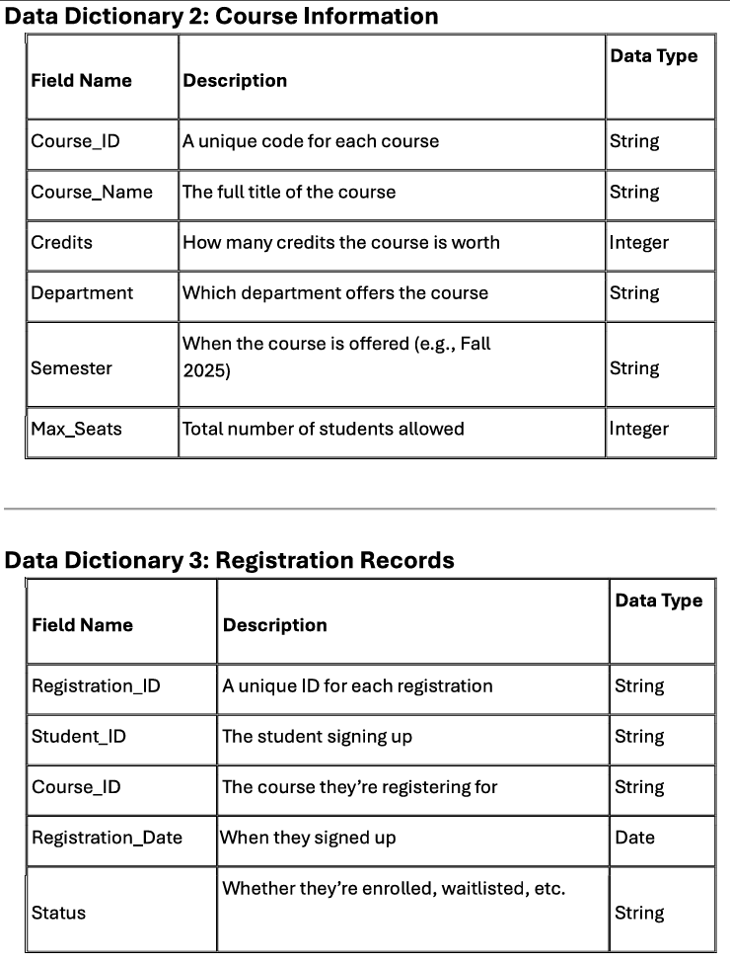
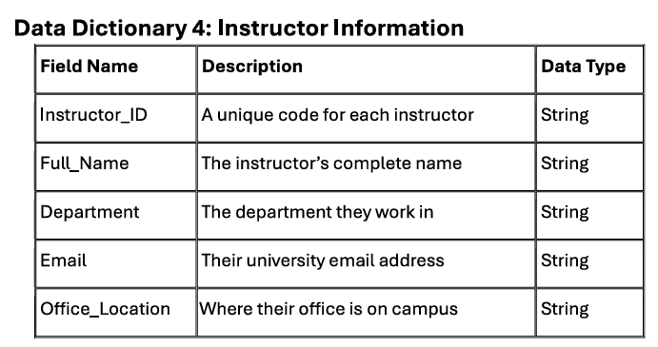

Additional Details
Student_ID and Course_ID act as connectors, linking registration records to the corresponding students and courses.
Fields such as Credits or Max_Seats use numeric data types (Integer) since they represent counts or limits.
The Status field in the Registration Records table might include values like "Enrolled," "Waitlisted," or "Dropped" to reflect the current enrollment situation.

Experiment 4

AIM: Draw level 0, 1, and 2 DFD (Data Flow Diagram) on the Online Course Registration system.

Introduction:
An Entity-Relationship (ER) Diagram is a graphical model that visualizes the entities and their relationships within a system. It is a critical component of the database design process, showing how data is organized and connected. ER diagrams help developers, designers, and stakeholders understand the system's architecture and data flow, which leads to a proper and efficient database design.

Components of an ER Diagram:
- Entities: Real-world objects or concepts represented as rectangles. Examples include Student, Course, Faculty, Department, and Admin.
- Attributes: Characteristics or properties of an entity, shown as ovals connected to their respective entities. For example: Student ID, Name, Age, Email for a Student.
- Relationships: Define how entities are associated with each other, represented by a diamond shape between entities.
- Cardinality: Specifies the number of instances of one entity related to another, indicated using notations like 1:1, 1:M (one-to-many), and M: N (many-to-many).

ER Diagram:

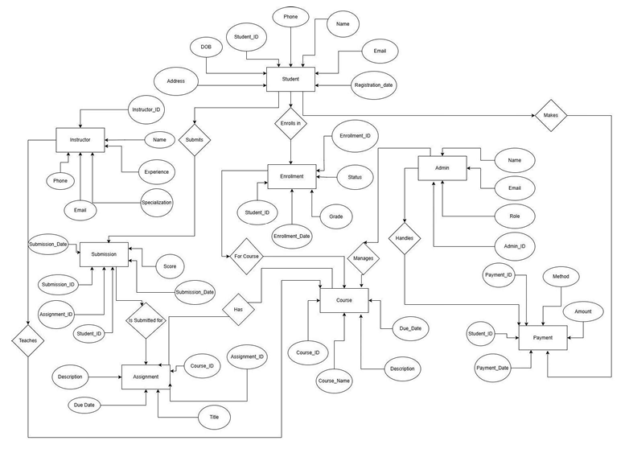

Conclusion:
The ER Diagram for an Online Course Reservation System provides a clear and structured visualization of the system's data relationships. It serves as a foundational blueprint for designing an efficient database, ensuring smooth data management, integrity, and security.

Experiment 5

AIM: Draw E-R diagram (Entity-Relationship diagram) of the Online Course Registration system.

1. Introduction
1.1 Purpose
The purpose of this SRS document is to define the functional and non-functional requirements for the Course Registration System. It serves as a reference for stakeholders, including developers, testers, project managers, and academic administrators, ensuring the project aligns with its objectives.
1.2 Scope
The Course Registration System is a web-based application designed to facilitate student enrollment in courses. The system allows students to browse, select, and register for courses, while administrators and faculty manage course offerings and class capacities. The aim is to streamline the registration process, improve efficiency, and ensure accurate record-keeping.
2. Overall Description
2.1 Product Perspective
The system integrates within the institution's academic management infrastructure, functioning as a standalone web application. It interacts with user roles such as students, faculty, and administrators.
2.2 Product Functions
- User Authentication: Secure login for students, faculty, and administrators.
- Course Catalog: Provides a list of available courses with details like prerequisites and schedules.
- Registration Process: Students can enroll in courses based on eligibility and availability.
- Prerequisite Verification: Ensures students meet requirements before registration.
- Seat Management: Tracks course capacities and waitlist management.
- Notifications: Sends email or system notifications for registration updates.
- Reports & Logs: Maintains records of course enrollments and student schedules.
- System Administration: Administrators can add/update courses, manage users, and generate reports.
2.3 User Classes and Characteristics
- Students: Users who browse courses, register, and manage their schedules.
- Faculty: Users who manage course content and track student enrollments.
- Administrators: Users who oversee course offerings, manage policies, and generate reports.
2.4 Operating Environment
The system will be a web application accessible via modern web browsers and hosted on a cloud-based or on-premise server. It will support Windows, Linux, and Mac OS environments.
3. Specific Requirements
3.1 External Interface Requirements
- User Interfaces: Shall provide a web-based GUI that is user-friendly and supports mobile and desktop access.
- Hardware Interfaces: Shall be accessible on any device with an internet connection.
- Software Interfaces: Integration with email services for notifications and a database connection for storing records.
3.2 Functional Requirements
- User Authentication: Users must log in; Role-based access control is required.
- Course Catalog: Display course descriptions, prerequisites, schedules, and real-time seat availability.
- Registration Process: Students can register for available courses; system shall prevent duplicate registrations.
- Prerequisite Verification: System shall validate prerequisite fulfillment before allowing registration.
- Seat Management: Enforce maximum seat limits; Waitlist functionality shall be implemented.
- Notifications: Automatic notifications for successful registration, waitlist updates, and course cancellations.
- Reports and Logs: Generate reports on enrollment trends and student schedules; Audit logs shall record user actions.
- System Administration: Administrators can add, update, or remove courses, and allow batch course updates for new semesters.
4. Non-functional Requirements
- Performance Requirements: Support concurrent users; Registration processing times shall not exceed 2 seconds.
- Security Requirements: All data transmissions shall be encrypted; Users shall be assigned appropriate role-based permissions.
- Usability Requirements: Intuitive interface with minimal training; Accessibility features shall be implemented.
- Reliability Requirements: Automated backups; System uptime shall be 99.9%.
- Scalability Requirements: Architecture shall support future expansion with minimal reconfiguration.
5. Other Requirements
- Legal and Regulatory Requirements: Comply with data privacy laws (e.g., GDPR) and institutional academic policies.
- Documentation Requirements: Provide User manuals and API documentation; include built-in help and tooltips

Experiment 6

AIM: Draw a class diagram for the Online Course Registration system.

Introduction:
The Use Case diagram for the Online Course Registration system outlines the various interactions between actors and the system itself. It illustrates the different functionalities and actions that users (actors) can perform within the system.
Diagram:
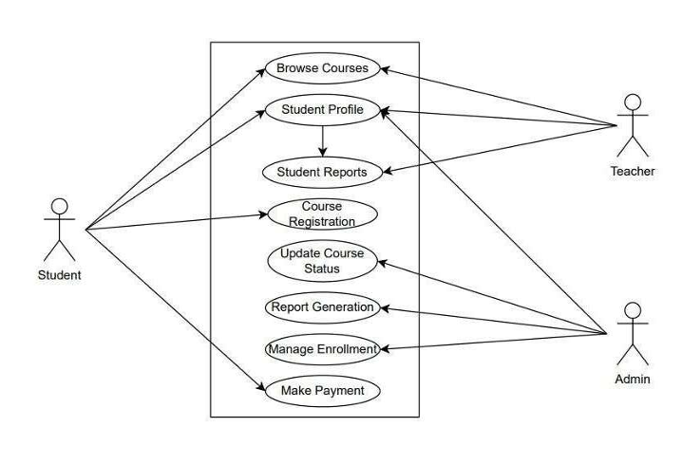
Actors:
- Student
  - Browse Courses
  - Apply for course registration
  - Make Payment
- Teacher
  - View Student Profile
  - Provide Student Reports
- Admin
  - Manage Courses
  - Manage Enrollments
  - Generate Reports for actions
Use Cases:
- Apply for Course Registration: Performed by Student to apply for registration in a course.
- Manage Courses Information and Status: Performed by Admin to update course information and status.
- Manage Enrollment: Performed by Admin to Add/Remove a student from a course.
- Generate Reports: Performed by Admin to generate reports and provide notifications to teachers and students.
- Provide Student Reports: Performed by teachers to give feedbacks and other reports to the student for their assignments, classes, etc..
Conclusion:
The Online Course Registration System use case offers a comprehensive solution to effectively manage course registration securely and efficiently. By integrating functionalities like payment processing, course management, student management, and user authentication, the system streamlines operations and enhances security.

Experiment 7

AIM: Write/design SRS (Software Requirements Specification) for the Online Course Registration system.

1. Introduction
The Software Design Document (SDD) outlines the architectural design, functionality, and specifications of the Course Registration System. It serves as a guide for developers, stakeholders, and users involved in the design, development, and implementation.
2. Roles and Responsibilities
- Development Team: Designing, coding, and testing the system.
- Project Manager: Oversees the project, ensures adherence to timelines and quality standards.
- Quality Assurance Team: Conducts testing to ensure the system meets requirements and is free from defects.
- Stakeholders: Provide input, feedback, and requirements for the system.
3. Overview
The Course Registration System aims to provide a comprehensive solution for managing course enrollments. The system will be designed to be user-friendly, secure, and scalable.
4. User Interface
The user interface will be intuitive and user-friendly, with features including:
- Login screen for students and administrators.
- Menu options for course search, registration, and schedule viewing.
- Registration confirmation and schedule printing.
- Admin panel for managing course offerings, student records, and system settings.
5. Function
- User Authentication: Verify user identity through student ID and password.
- Registration Processing: Handle course searches, enrollments, and schedule generation.
- Course Management: Monitor course availability, update details, and manage prerequisites remotely.
- Reporting: Generate reports on enrollment statistics, course usage, and system performance.
6. Scope
The Course Registration System will include the following features:
- User authentication and authorization.
- Course registration and scheduling.
- Course monitoring and management.
- Reporting and analytics.
7. Milestones
- Phase 1: Requirements Gathering and Analysis - Define system requirements; Identify stakeholders and gather feedback; Analyze existing registration workflows.
- Phase 2: Design and Architecture - Create high-level and detailed design documents; Define system architecture and components; Prototype user interface and system modules.
- Phase 3: Implementation and Testing - Develop system modules and components; Conduct unit testing and integration testing; Perform system testing and validation.
- Phase 4: Deployment and Maintenance - Deploy the system to production environment; Provide user training and support; Monitor system performance and address issues.
8. Glossary/Annexure
- CRS: Course Registration System.
- Student ID: Unique identifier for each student.
- Prerequisites: Courses required before registration in another course.

Experiment 8

AIM: Design test cases for the inventory management system using boundary value method.

Introduction:
In software development, prototypes are essential for visualizing, refining, and validating a system's design and functionality before full-scale development begins. The prototype for the Course Registration System demonstrates the core functionalities of the registration process. It provides stakeholders with an interactive model to provide feedback and suggest improvements early on.
Objectives of the Prototype for the Course Registration System:
- Visualization: Offers a graphical representation of the system's interface, navigation flow, and layout. Stakeholders can interact to understand registration, approvals, and record management.
- Feedback Gathering: Stakeholders can evaluate the ease of use, design, and workflow. Early feedback helps refine UI/UX design, feature integration, and process efficiency.
- Validation of Requirements: Helps validate system requirements by demonstrating core functionalities like course registrations, approvals, and reporting. Ensures the system aligns with institutional policies and user needs.
- Risk Mitigation: Identifying design flaws, usability issues, or missing features at the prototype stage prevents costly changes later.
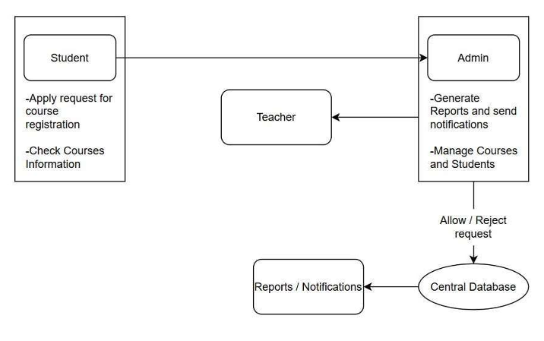
Conclusion:
The prototype for the Course Registration System plays a vital role in the development lifecycle by offering stakeholders an early glimpse into the system's design and functionality. It serves as a catalyst for driving the development process forward efficiently and effectively through visualization, feedback gathering, and requirement validation.

Experiment 9

AIM: Write a program in C to implement COCOMO model.

CODE:
#include <stdio.h>
#include <math.h>
#include <stdlib.h>

typedef struct {
double a;
double b;
double c;
double d;
char mode_name[20];
} CocomoConstants;

int get_cocomo_mode() {
int choice;
printf("\n--- Basic COCOMO Model Estimation ---\n");
printf("Select the Development Mode:\n");
printf("1. Organic (Simple, small teams, experienced)\n");
printf("2. Semi-detached (Intermediate, mixed experience)\n");
printf("3. Embedded (Complex, rigid constraints, high reliability)\n");
printf("4. Exit\n");
printf("Enter your choice (1-4): ");
scanf("%d", &choice);
return choice;
}

void calculate_cocomo(double kloc, const CocomoConstants *constants) {
double effort_pm, time_months, staff_size;

effort_pm = constants->a * pow(kloc, constants->b);

time_months = constants->c * pow(effort_pm, constants->d);

staff_size = effort_pm / time_months;

printf("\n--- Estimation Results for %s Mode ---\n", constants->mode_name);
printf("Software Size (KLOC) : %.2f\n", kloc);
printf("Estimated Effort (Person-Months): %.2f PM\n", effort_pm);
printf("Estimated Development Time (Months): %.2f Months\n", time_months);
printf("Average Required Staff Size : %.2f Personnel\n", staff_size);
printf("--------------------------------------------------\n");
}

int main() {
CocomoConstants organic = { 2.4, 1.05, 2.5, 0.38, "Organic" };
CocomoConstants semidetached = { 3.0, 1.12, 2.5, 0.35, "Semi-detached" };
CocomoConstants embedded = { 3.6, 1.20, 2.5, 0.32, "Embedded" };

int choice;
double kloc;

while (1) {
choice = get_cocomo_mode();

if (choice == 4) {
printf("Exiting COCOMO Estimator. Goodbye!\n");
break;
}

if (choice >= 1 && choice <= 3) {
printf("\nEnter the size of the software in KLOC (Kilo Lines of Code, e.g., 50.5): ");
if (scanf("%lf", &kloc) != 1 || kloc <= 0) {
printf("Invalid input. Please enter a positive number for KLOC.\n");
while (getchar() != '\n');
continue;
}

switch (choice) {
case 1:
calculate_cocomo(kloc, &organic);
break;
case 2:
calculate_cocomo(kloc, &semidetached);
break;
case 3:
calculate_cocomo(kloc, &embedded);
break;
default:
printf("Invalid choice.\n");
}
} else {
printf("Invalid selection. Please choose a number from 1 to 4.\n");
}
}

return 0;
}

OUTPUT:

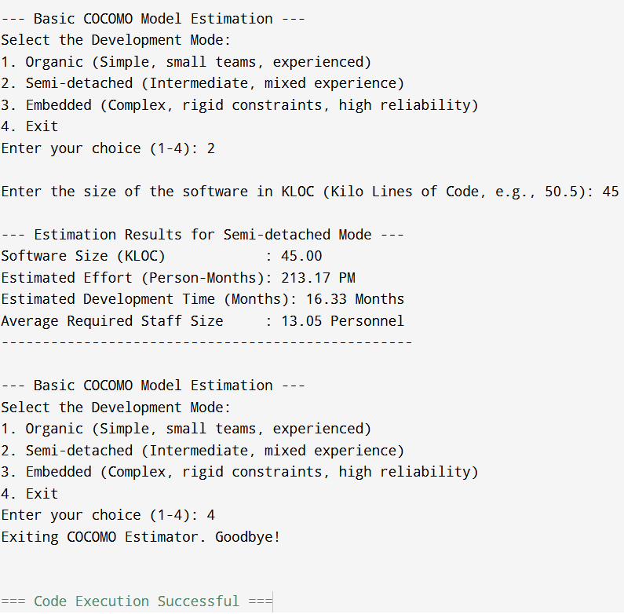

Experiment 10

AIM: Write a program in C to implement function point method.

CODE:

#include <stdio.h>
#include <stdlib.h>
#include <math.h>

const int WEIGHTS[5][3] = {
{3, 4, 6},
{4, 5, 7},
{3, 4, 6},
{7, 10, 15},
{5, 7, 10}
};

const char *COMPONENT_NAMES[] = {
"External Inputs (EI)",
"External Outputs (EO)",
"External Inquiries (EQ)",
"Internal Logical Files (ILF)",
"External Interface Files (EIF)"
};

const char *GSC_NAMES[14] = {
"Data Communications", "Distributed Data Processing", "Performance",
"Heavily Used Configuration", "Transaction Rate", "Online Data Entry",
"End-User Efficiency", "Online Update", "Complex Processing",
"Reusability", "Installation Ease", "Operational Ease",
"Multiple Sites", "Facilitate Change"
};

double calculate_ufp();
int get_rating(const char *gsc_name);
double calculate_vaf();
void calculate_and_display_results(double ufp, double vaf);

int main() {
printf("\n=======================================================\n");
printf(" Software Size Estimation: Function Point Method\n");
printf("=======================================================\n");

double unadjusted_fp = calculate_ufp();
printf("\n[STEP 1 COMPLETE] Unadjusted Function Points (UFP) = %.2f\n", unadjusted_fp);

double value_adjustment_factor = calculate_vaf();
printf("\n[STEP 2 COMPLETE] Value Adjustment Factor (VAF) = %.2f\n", value_adjustment_factor);

calculate_and_display_results(unadjusted_fp, value_adjustment_factor);

return 0;
}

double calculate_ufp() {
double total_ufp = 0.0;
int counts[3];

printf("\n--- Step 1: Calculate Unadjusted Function Points (UFP) ---\n");
printf("Please enter the count for each component type and complexity.\n");

for (int i = 0; i < 5; i++) {
printf("\nComponent: %s\n", COMPONENT_NAMES[i]);

for (int j = 0; j < 3; j++) {
const char *complexity_name = (j == 0) ? "Low" : (j == 1) ? "Average" : "High";
printf(" Enter count for %s complexity: ", complexity_name);

if (scanf("%d", &counts[j]) != 1 || counts[j] < 0) {
printf("Invalid input. Please enter a non-negative integer.\n");
while (getchar() != '\n');
j--;
continue;
}

total_ufp += (double)counts[j] * WEIGHTS[i][j];
}
}

return total_ufp;
}

int get_rating(const char *gsc_name) {
int rating;
while (1) {
printf(" %02d. %-30s (0-5): ", (int)(gsc_name - GSC_NAMES[0]) / sizeof(char *) + 1, gsc_name);
if (scanf("%d", &rating) == 1 && rating >= 0 && rating <= 5) {
return rating;
} else {
printf("Invalid input. Please enter a rating between 0 (No Influence) and 5 (Strong Influence).\n");
while (getchar() != '\n');
}
}
}

double calculate_vaf() {
int total_di = 0;

printf("\n--- Step 2: Rate General System Characteristics (GSCs) ---\n");
printf("Rate each characteristic on a scale of 0 to 5:\n");
printf(" (0: No Influence, 1: Incidental, 2: Moderate, 3: Average, 4: Significant, 5: Strong)\n");

for (int i = 0; i < 14; i++) {
total_di += get_rating(GSC_NAMES[i]);
}

printf("\nTotal Degree of Influence (DI) = %d\n", total_di);

double vaf = 0.65 + ((double)total_di / 100.0);

return vaf;
}

void calculate_and_display_results(double ufp, double vaf) {
double adjusted_fp = ufp * vaf;

const double PH_PER_FP = 10.0;
double effort_hours = adjusted_fp * PH_PER_FP;
double effort_months = effort_hours / (8.0 * 22.0);

printf("\n=======================================================\n");
printf(" FINAL ESTIMATION RESULTS\n");
printf("=======================================================\n");
printf("Unadjusted Function Points (UFP): %.2f FP\n", ufp);
printf("Value Adjustment Factor (VAF): %.3f\n", vaf);
printf("-------------------------------------------------------\n");
printf("ADJUSTED FUNCTION POINTS (AFP): %.2f FP\n", adjusted_fp);
printf("-------------------------------------------------------\n");
printf("Estimated Total Effort:\n");
printf(" @ %.1f Person-Hours/FP: %.0f Person-Hours\n", PH_PER_FP, effort_hours);
printf(" Estimated Project Duration: %.2f Person-Months\n", effort_months);
printf("=======================================================\n");
}

OUTPUT:

